Does peer grading work? How to implement and improve it? Comparing instructor and peer assessment in MOOC GdP
Remi Bachelet, Drissa Zongo, Aline Bourelle
To cite this version: Remi Bachelet, Drissa Zongo, Aline Bourelle. Does peer grading work? How to implement and improve it? Comparing instructor and peer assessment in MOOC GdP. European MOOCs Stakeholders Summit 2015, May 2015, Mons, Belgium. Proceedings of the Research Track. <halshs-01146710v2> HAL Id: halshs-01146710 https://halshs.archives-ouvertes.fr/halshs-1146710v2 Submitted on 12 May 2015 HAL is a multi-disciplinary open access archive for the deposit and dissemination of scientic research documents, whether they are published or not. The documents may come from teaching and research institutions in France or abroad, or from public or private research centers. L'archive ouverte pluridisciplinaire HAL, est destinee au dep^ot et a la diusion de documents scientiques de niveau recherche, publies ou non, emanant des etablissements d'enseignement et de recherche francais ou etrangers, des laboratoires publics ou prives.

Does peer grading work? How to implement and improve it? Comparing instructor and peer assessment in MOOC GdP

Remi BACHELET, Drissa ZONGO, Aline BOURELLE
Ecole Centrale de Lille, BP 48, F-59651 Villeneuve d'Ascq Cedex, France
remi.bachelet@ec-lille.fr, drizongo@gmail.com, alinebourelle@msn.com

Abstract: Large scale peer assessment is arguably the most critical innovation required for development of MOOCs. Its core principle is to involve students in the evaluation and feedback process of correcting assignments. However, it has been criticized for being less rigorous than instructor assessment, too demanding on students and not reliable or fair due to student biases. This paper is drawn from data and practical hands-on experience from MOOC GdP2, in which assignments were both graded by instructors and by peers. Using data from 4650 papers, each graded by 3-5 peers and by an instructor, we test hypotheses and discuss a series of questions: How to train MOOC students to grade their peers? Is peer grading as accurate as instructor grading? What data pre-processing is to be used prior to testing hypotheses on peer grading? Which grading algorithm is best for processing peer-produced data? Is anonymity in peer assessment preferable to increased student interaction? We also present the improved peer grading systems we implemented in MOOC GdP 3 and 4 thanks to this research.

Keywords: Massive open online courses, MOOC, peer assessment, peer grading.

Introduction

Despite recent attempts at improving platforms and course quality, the pedagogy of most MOOCs today rely mostly on two things: video courses and quizzes. The strength of these technologies comes from how easily they can be deployed on a massive scale, but their weakness lies in their inability to process, grade and provide feedback for complex and open-ended student assignments and overall supporting activities for critical thinking. We believe that the solution to this challenge is not machine grading (Burrows, Gurevych & Stein, 2014), but peer grading, and more broadly, peer assessment. More than a promising solution to evaluate assignments on a massive scale, peer assessment holds the promise of major learning benefits, developing student autonomy and, in Bloom's taxonomy, higher levels of learning (Bachelet 2010, Sadler & Good 2006).

But is it really possible to implement peer evaluation? Does it provide reliable results? How to minimize student’s workload while retaining accurate peer grading? In this paper, we shall address a series of questions through experience of four MOOC GdP sessions and quantitative data from the second session of the MOOC:

1. Qualitative/experience testing: How to train MOOC students to grade their peers and provide them with constructive feedback as well?
2. Quantitative data/hypothesis testing: Is peer grading as accurate as instructor grading?
3. Quantitative data/hypothesis testing: What data pre-processing is to be used to test hypotheses on peer grading?
4. Quantitative data/hypothesis testing: Which grading algorithm is best for processing peer-produced data in order to deliver grades which are similar to instructor grading?
5. Quantitative data/hypothesis testing: How many peer grades are required to provide an accurate final grade?
Amongst the four sessions of the "fundamentals of project management" MOOC, the second session is the best fit for exploring these issues, mostly because:
. We have a significant dataset: 1011 to 831 assignments were submitted each week, for 5 weeks, 4650 assignments total.
. A large variety of assignments : 1/a concept map, 2/a series of slides comparing alternative projects, 3/a meeting report with an allocation of tasks, 4/ specifications and functional analysis of a project and 5/a Gantt chart
. Last but not least, a comparison of instructor and peer grading was readily available: there were both 35 peer grades and one instructor/AT grading (considered as the “true score”) for each student assignment.

Context
MOOC GdP1 was the first xMOOC to be organized in France, it was developed from an existing Open Course Ware (OCW) website (Bachelet, R. 2012a) and experience of running a distance learning course (8 editions, 400 laureates from 2010 to 2012, see Bachelet, R. 2012b). It was set up with almost no financial resources using a personal home studio and run by an open team of volunteers. Three external actors brought support: Ecole Centrale de Lille sponsored the project, various Free Google services were used (Google groups, Drive, Hangouts, YouTube) and the US Company Instructure hosted the course on the Open source MOOC application Canvas. Enrollment opened January 11, 2013, course started March 18 and offered two individual tracks: Basic and Advanced. A “Team project” track was also proposed after the individual tracks, it ran 14 projects and was instrumental in recruiting volunteers supporting the next editions of the MOOC.

MOOC GdP2 followed the same principles, but was one week longer, adding a functional analysis course. Beside the free tracks, it became for the first time possible to be awarded European University Credits (ECTS) by Centrale Lille, by taking either a webcam (ProctorU) or an on-site table exam (AUF campuses in two developing countries). Technical support for Canvas was provided by the French startup Unow. All non-foreign Centrale Lille first year engineering students (approximately 200 of the 1011 students of this track) were enrolled in the advanced track, as required by their curriculum.

Basic and advanced tracks started September 16, 2013. MOOC GdP2 was 5 weeks long, plus one week dedicated to preparing the final exam. A one week add-in SPOC session on Project Evaluation was organized from November 4 for employees of Agence Universitaire de la Francophonie, and the Team project track of the MOOC started mid-October (sharing project ideas, putting the teams together) and ended mid-December with a final video presentation and report.

Attendance was as follow -enrolled: 10848, completing at least one quiz for the basic track: 5711, submitting at least one deliverable for the advanced track: 1011.

Success rates (Bachelet, R. 2013) were:
. Entry rate, 53%: this ratio is the number of students submitting at least one short quiz divided by total enrollment in the MOOC, thus there was a 47% population of “no-show” and auditors.
. Basic track pass rate, 61%: calculated as follow -the number of students submitting at least one short quiz divided by the number of students awarded with basic track “pass” (i.e. an average of 70% of maximum points and 60% of maximum points on the final exam)
. Advanced track success rate 78%: the number of students submitting at least one assignment divided by advanced track “pass” (i.e. basic track “pass”, plus an average of 70% of total maximum points).

Advanced track: organization and assignments

Students undertaking the advanced track were required to submit an assignment each week, in relation to a topic covered in the week's course. After that, each student was randomly allocated 4 assignments submitted by other students. He/she had to: 1/provide feedback to the student (comments could be global, specific to a grading category or “comment bubbles” inserted on the pdf assignment) and 2/grade from 0 to 100 (70/100 being the expected “pass” grade) according to a 4-items rubric. Instructions for evaluation as well as other systems were provided to help grading and feedback, which will be described more thoroughly below. Students had 5 days to complete the peer evaluation process after which it was closed and the teaching team started awarding final grades.

Assignments were: 1/a concept map, 2/a series of slides comparing possible projects, 3/a meeting report with an allocation of tasks, 4/ specifications and functional analysis and 5/a Gantt chart (figures 1 to 3)
Each assignment required 4-9 hours of work, depending on previous skills and knowledge. Plagiarism was detected using Euphorus (1-3% of submissions, later removed from our dataset).

Table 1: Assignments overview (from Bachelet, R. Petit, Y. (2014).

 | # of papers submitted | average final grade | standard deviation of grades
paper 1 : concept map | 997 | 61.6 | 20.71
paper 2 : investment study (slides) | 1011 | 69.5 | 21.5
paper 3 : meeting report | 944 | 72.5 | 16.24
paper 4 : functional analysis | 867 | 69.6 | 20.96
paper 5 : Gantt chart | 831 | 74.2 | 22.56

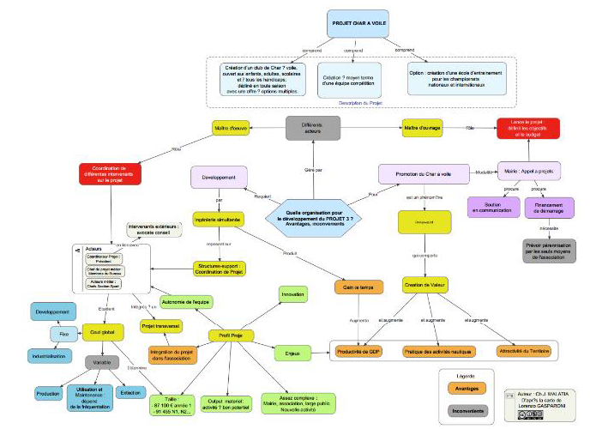
Figure 1.1 Week 1 assignment: concept map

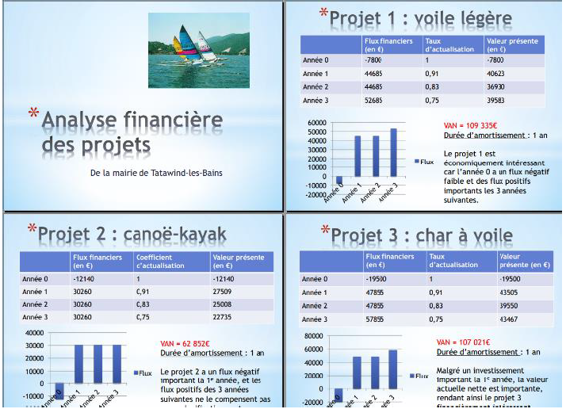
Figure 1.2 Week 2 assignment: investment study.

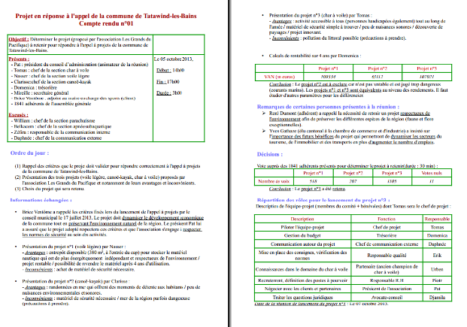

Figure 2.1. Week 3 assignment: meeting report

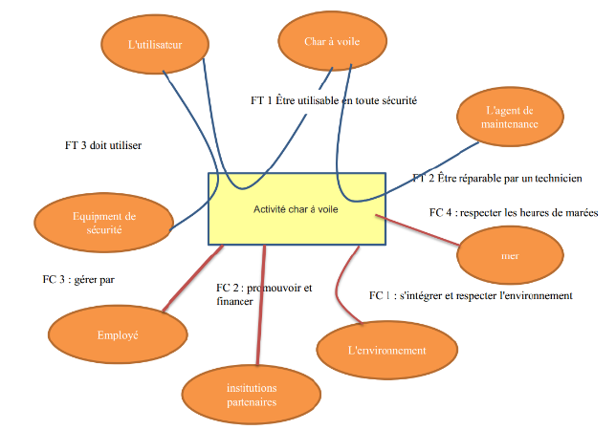
Figure 2.2 Week 4 assignment: functional analysis.

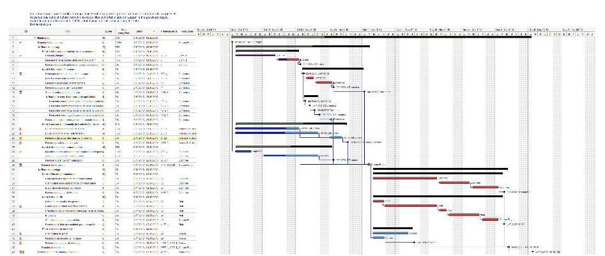

Figure 3. Week 5 assignment: Gantt chart.

How to train and empower MOOC students so that they can grade their peers and provide them with constructive feedback?

Several systems were developed, some generic to MOOCs and peer grading in general, and some dedicated to grading specific assignments of MOOC GdP2.

Generic peer Evaluation training:
. Peer grading and evaluation was claimed from the start as a major requirement of the advanced track (“learning agreement” presented in the teaser and “introduction to advanced track” video).
After submission of the first essay, a video was dedicated to explaining the rationale and importance of peer assessment in MOOCs and how to write motivating and constructive feedback.

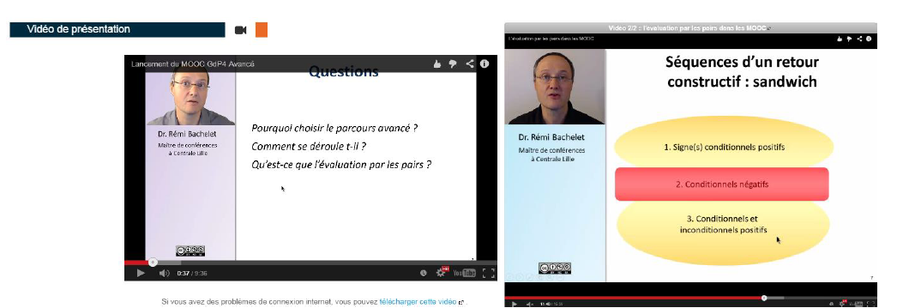

Figure 4.1 “Introducing peer evaluation in the advanced track”
Figure 4.2 “Generic peer Evaluation training”.

Specific peer Evaluation training:

In addition, specific resources were available to guide peer evaluators in assessing each assignment: a benchmark version of the assignment, a video (sometimes), an interactive grading rubric and a discussion thread (1649 total forum posts on assignments and peer evaluation in GdP2). Guidelines on how to use the platform for peer grading were also provided.

Anonymity

Unlike most other studies of peer assessment in MOOCs, while anonymity is possible in MOOC GdP (using a pseudonym as one's platform profile), it is rarely used. On the contrary, students are encouraged to exchange messages via the Canvas platform message system, even only for a “thank you” to their evaluators. Messages make it also possible to ask an evaluator to revisit the assigned grade or to give additional feedback. Though we have no data on messages exchanged on these occasions, we believe that there is much more to gain by fostering social contacts between students than there are risks of conflicts or bias in grading. Biases in grading can be controlled using either instructor grading (MOOC GdP 1 and 2) or a grading process and algorithm (MOOC GdP 3 and 4). Though the legitimacy of student grading is often questioned. Conflicts between persons are rare: Instructor staff can be called upon if student’s interactions get sour: we had to intervene on only one such occasion in the 4 editions of MOOC GdP (more than 10.000 assignments assessed by 3-4 peers).

Critics point out that there is a bias assessing someone you can identify (besides googling the person, you can know him/her first hand, especially for the 200 Centrale Lille students). To minimize biases, the final grade was issued by an instructor in GdP1 and 2 while a control and a reward system was designed for GdP 3 and 4 (described below).

What data pre-processing is to be used to test hypothesis on peer grading?

Before starting quantitative analysis of grades, we studied the data distribution and consistently found the same pattern (figures 5.1 and 5.2):

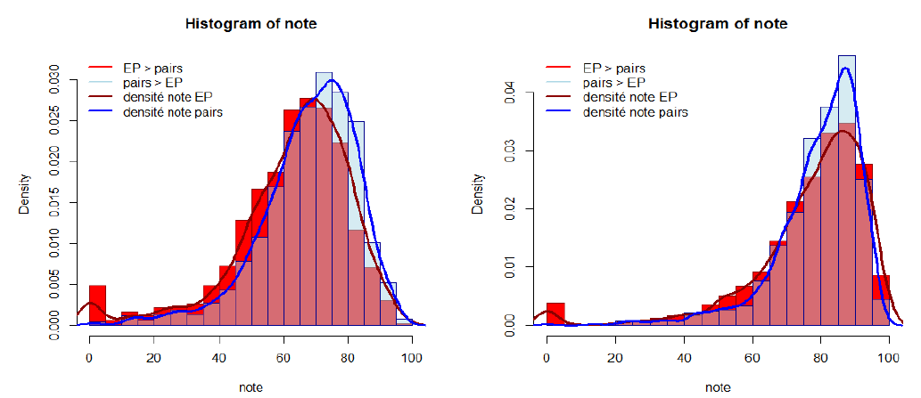
Figure 5.1 and 5.2 Data Pattern of peer and instructor grades Assignments 1 and 5

Red filing: instructors assign higher grades, blue filling if not. Red and blue lines are grades density

Two problems were highlighted:
1. A peer/instructors grading discrepancy with the “0” grade.
2. The shape of the grades distribution does not seem to be a Gaussian/Normal distribution (“bell curve”).

The discrepancy with the “0” grade is illustrative of plagiarism: peers issue a “normal grade”, while instructor’s grade is 0. It is simple to fix: we pre-process and filter these grades out. The second issue: the shape of the grades distribution not being a normal distribution, is confirmed visually (data distributions is “leftskewed”), as well as by a Shapiro-Wilk normality test. This constitutes a major hurdle since all standard statistical tests for hypotheses work under the assumption that data fits a normal distribution.

We used EasyFit (Schittkowski, K. 2002) to test a match with a series of known distributions, without finding a single simple best fit for all assignments. As a consequence and in order get a closer fit to a normal distribution, we decided to go for a basic pre-processing variable change matching the simplest fit, a Log-normal distribution: ln(100-grade). Figure 6 displays the very same data as above, after the change of variable and filtering out plagiarism.

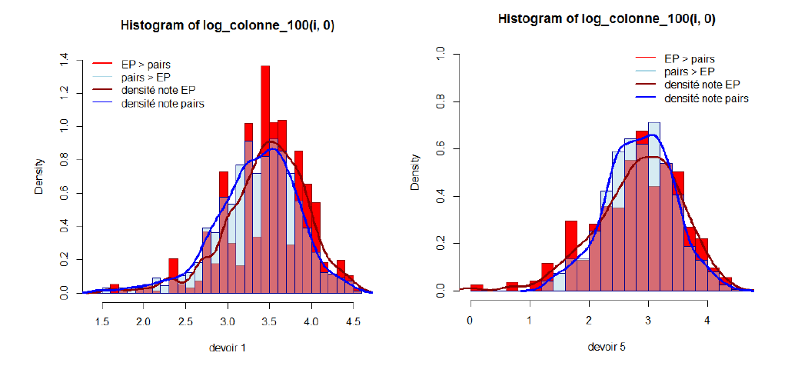
Figure 6.1 and 6.2 Filtered Data Pattern of peer and instructor grades for assignments 1 and 5

While the new data distribution is not really a normal distribution, it is now much closer to it. Using this new dataset to conduct confirmatory data analysis improves the validity of our study.

Is individual peer grading as accurate as instructor grading?

Literature on peer grading offers contrasting views on this issue (Bachelet 2010, Doiron, G. 2003, Sadler & Good 2006). In Sadler & Good (2006), peer grades are highly correlated with instructor grades r = 0.905, while we find an average correlation of 0,772 with a p-value <2.2e-16 (Pearson correlation, data processing with R version 3.1.1). In our dataset, with consideration to the difference between instructor and peer grade results are as follow: 36% of grades are extremely similar (±5 points on a scale of 100), 60% very similar (±10 points), 85% dissimilar (±20 points off).

Now what precision can reasonably be expected? It is widely recognized that different instructors grading an essay does not give the same grade. But what actual precision does instructor grading provide? While we did not find research in English on this question, French education science research on grading (docimologie) can provide us with a benchmark on the convergence when different instructors grade a given essay. According to Suchaut, B. (2008)i: 5, 10 and 20% convergence of individual instructor’s grades to average grade is: 39%, 65% and 91%. While this is better than the 36%, 60% and 85% we get with student grading, we need to test whether processing several peer grades instead of using only one will perform better.

Which grading algorithm is best for processing peer-produced data in order to deliver grades which are similar to instructor grading?

Beyond “one shot” individual grading, MOOCs allows for improving grading accuracy by using several peer grades. Our goal with students taking part in MOOC GdP2 was to require 5 peer assignments grades, but with platform allocation issues and defections they were 0-6 grades given, and on average 3.57 to 4.67 peer grades for each assignment (with 6 to 11% of students not taking part in peer evaluation at all).

Is it possible to improve the precision of grading by using not one, but several peer grades? Before that, we need to determine the best algorithm for processing peer grades. While sophisticated methods exist, like Calibrated Peer Reviews, Credibility index (Suen, H. 2014), or Bayesian post hoc stabilization (Piech, C. et al. 2013), we shall stick to the most common and understandable methods which are grades average and grades median. Each has strong and weak points (average uses all available data, while median is “robust” as it filters out extreme values…). While using the average is the usual way to go, Coursera MOOC platform uses median. In order to find the best method, we study two “error functions”: the difference either of the average or the median of students grades with instructor grades. Our research shows using the average as slightly more accurate (1 point on a 100-points scale), see figures 7.1 and 7.2 below.

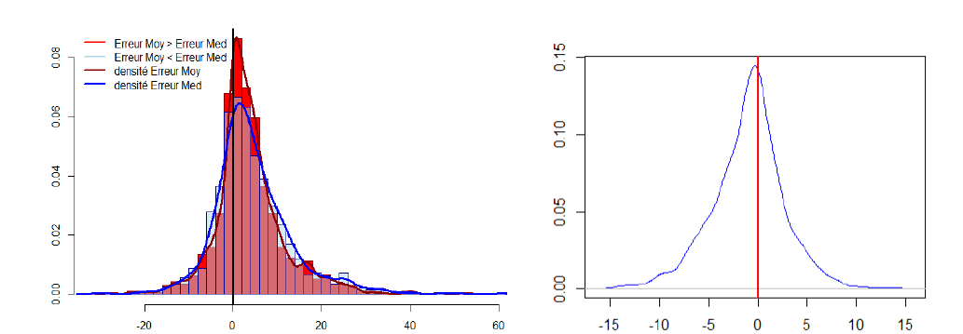
Figure 7.1 Error function of average (brown) median (blue) 7.2. Difference (ErrorWithAverage – ErrorWithMedian)

How efficient is the average peer grade algorithm?

With consideration to the difference between instructor and peer grade and using all the available peer data 56.6% of average grades are extremely similar to instructor grades (±5 points on a scale of 100), 82.6% very similar (±10 points) and so, approx. 17% of assignments are graded more than 10 points off). Figures 8.1 and 8.2 show a comparison of average peer grades and instructor grades: it highlights the fact that 1/ the peer average algorithm gives very slightly higher grades (2.6 points on a 100 scale) and 2/ 13.9 average std deviation.

This claim is supported by literature on instructor grading consistency, (Suchaut B. 2008) which shows that instructors grading a series of identical assignments have a consistency measured by standard deviation of 15. In this regard, this peer evaluation system performs better than instructors.

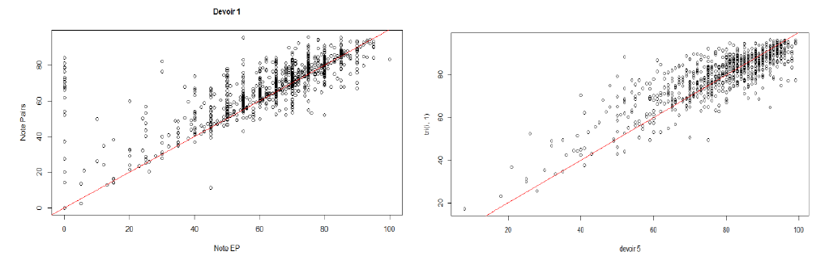
Figure 8.1. Average peer grades vs. instructor grades in Assignment 1 and Fig 8.2 in Assignment 5
x axis is instructor grade, y is average of students grades

How many peer grades are required to correctly estimate “best grade”?

Does grading precision improve with the number of peer grades we take into consideration? How many are required to have an optimum end grade? To study this question using R version 3.1.1, we make a series of “what if” simulations in which 1, 2, 3, 4 or all peer grades are used to calculate the average peer grade. Then checking what proportion of the final grade is close to instructor’s grades.

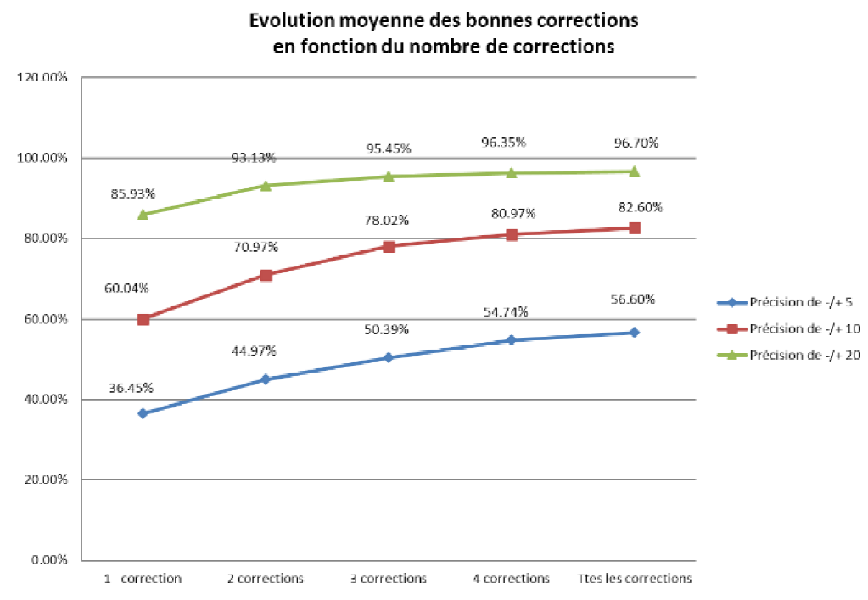
Figure 9. : 5, 10 and 20% accuracy of average peer grades to instructor grades vs. number of peer grades

Data shows that taking into account more peer grades consistently improve the accuracy of grading, though with decreasing returns.

Although in this case peer grading quickly performs better (with two peers), than instructor’s grading (as stated before according to Suchaut, B. 2008 5, 10 and 20% convergence of individual instructor’s grades to average grade is 39%, 65% and 91%), it is our opinion that the best “return for work” appears with 3-4 peer grades, as our graph shows a quick improvement going from 1 to 3 peer grades.

Improving peer evaluation monitoring and grades processing in MOOC GdP3 and 4

This study was conducted with GdP2 data, but since then we have experimented new avenues of work and improved the design and management of the advanced track:
. During MOOC GdP3, we estimated students grading bias with a benchmark assignment and calculated final grades using the average of bias-corrected grades. We also saved a lot of teaching-staff time by drastically reducing instructor grading in favor of peer grading: instead of using 100% instructor grading, we implemented “targeted instructor grading”. Based on a series of warning indicators (such as “too few peer grades”, “non-consensus amongst peers”) we were able to make progress, going from 100% instructor grading to 10% instructor grading. We also initiated a messaging system before they grade the next assignment, providing feedback to peer graders that were clearly “off”, grading to high or too low.
. In MOOC GdP4, using the results presented in this paper, we were able to estimate the quality of grades issued by peers and act on this information: a dedicated VBA/Excel application (Benbitour M. H., Bachelet, R. Zongo D. 2014) was developed to provide feedback on whether each grade was correct, high or low and reward accurate grading with bonus points (or issue negative points when grossly inaccurate grades we given or when grading work was simply “not done” see figure 10). We were able to track whether peer grading improved with time and successive assignments. We also detected assignments with less peer grades and set up an extra peer assignment attribution session in order to insure the availability of at least 3 peer grades for each assignment. Also, we implemented self-evaluation of submissions (using the additional self-grade in a new algorithm). Adding self-evaluation is an important advance, as Sadler & Good (2006) point out it is the best source for learning (even better than peer evaluation itself). In the new system, developed for Canvas in association with Unow, students were asked to get a fresh look at their own work and grade it after having evaluated at least 3 other student’s assignments.

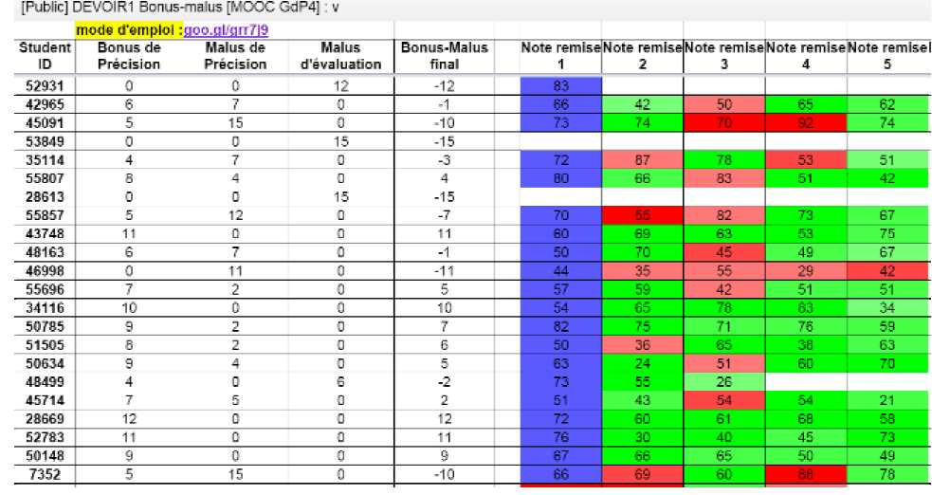
Figure 10: Application of this research – providing feedback and rewarding peer grading in MOOC GdP4

Conclusions and recommendations to researchers and MOOC designers

While it has promising potential, peer grading is not easy to implement: not only does it require careful work, beta testing and setting up a new case study each session, but also dedicated data processing and expertise in the instructors and technical teams. Carefully setting up the peer assessment protocol itself is paramount: deadlines, reminders, targeted messages, deciding how each student gets feedback on the quality of the grades that were assigned to him/her and. Rewards for accurate grading must be provided, along with penalties when grading is incorrect or has not been submitted. Moreover, although the instructor team is not required to grade all papers anymore, monitoring and manual grading is still required on occasions.

Our final recommendations to practitioners are:
. Researchers should first look closely at peer grades distribution: it needs to be filtered and a variable change can bring considerable improvement in hypothesis testing validity.
. How many assignments should a student be required to grade? We recommend four as the best compromise to obtain a quality final grade, accounting for peers who could drop out of the process and to leave time to work on issuing one additional grade, which would be a self-assessment.
. What algorithm should be preferred? Use average if grading data has been correctly checked and filtered. Otherwise, median is probably the best way to go.
. The optimum threshold to switch from automatic peer grading to instructor grading remains to be determined. We used three criteria: less than 2 peer grades, non-consensus (i.e. peer grades standard deviation >20) and presence of a 0 grade. Thus in GdP4, respectively 10%, 9% and 1.6% of assignments 1, 2 and 3 were graded manually (Bachelet, R. Carton P-A. 2015).

Before concluding our paper, we have to stress one more time the major importance of using quality learning materials, good peer training and sound incentives so that the conditions for peer assessment are optimal. Hard work and dedication of instructors, as well as MOOC platform ergonomics and functionalities are also paramount. It is regrettable that all these vital elements in peer grading are overlooked in most studies: having “lots of data” and “sophisticated algorithms” is important, but secondary to setting up the best possible conditions for peer evaluation and peer learning.

Software and data sources all retrieved 15/02/2015

Bachelet, R. (2012a). Cours et MOOC de gestion de projet : formations en video, ppt, pdf et modeles de documents from: http://gestiondeprojet.pm
Bachelet, R. (2012b). Formation a distance en gestion de projet, Retrieved, January 11, 2015, https://sites.google.com/site/coursgestiondeprojet
Bachelet, R. (2013). Analytics et taux de reussite du MOOC GdP 2 (septembre-decembre 2013)
http://goo.gl/Ia7Syw
Bachelet, R. Carton P-A. (2015). Analytics et taux de reussite du MOOC GdP 4 (septembre-decembre 2014) http://goo.gl/RC8JLV
Bachelet, R. Petit, Y. (2014). Gradebook of MOOC GdP 2 Extracted from Canvas MOOC platform, December 20, 2014
Benbitour M. H., Bachelet, R. Zongo D. (2014). Traitement des notes des evaluations par les pairs du MOOC GdP3 et 4, Excel Visual Basic Speadsheet http://goo.gl/1UGNTX
Schittkowski, K. (2002). Easy-Fit: a software system for data fitting in dynamical systems. Structural and Multidisciplinary Optimization, 23(2), 153-169. http://www.mathwave.com

References

Bachelet, R. (2010). Le tutorat par les pairs in Le tutorat par les pairs" in Accompagner des etudiants, direction Verzat C. Villeneuve L. Raucent B. De Boeck, ISSN 0777-5245

Bachelet, R. (2014). Les MOOC, analyse de dispositifs, Evaluation par les pairs, Atelier n°1 : Les MOOC : analyse de dispositifs mediatises et d’usages par des apprenants Colloque TECFA e-learning 3.0, Universite de Geneve, 17-18 octobre 2014 http://gestiondeprojet.pm/mes-contributions-sur-les-mooc

Bachelet, R., Cisel, M. (2013). Evaluation par les pairs au sein du MOOC ABC de la Gestion des projets: une etude preliminaire. Atelier MOOC, EIAH, Toulouse http://goo.gl/6JHYOv

Cisel, M., Bachelet, R. Bruillard E. (2014). Peer assessment in the first French MOOC: Analyzing assessors' behavior. Proceedings of International Educational Data Mining Society. http://goo.gl/2YNPhw

Doiron, G. (2003). The value of online student peer review, evaluation and feedback in higher education. CDTL Brief, 6(9), 1-2. http://www.cdtl.nus.sg/Brief/Pdf/v6n9.pdf

Piech, C., Huang, J., Chen, Z., Do, C., Ng, A., & Koller, D. (2013). Tuned models of peer assessment in MOOCs http://arxiv.org/pdf/1307.2579.pdf

Sadler, P. M., & Good, E. (2006). The impact of self-and peer-grading on student learning. Educational assessment, 11(1), 1-31 http://goo.gl/giznLS

Steven Burrows, Iryna Gurevych, Benno Stein. (2014) The Eras and Trends of Automatic Short Answer Grading. International Journal of Artificial Intelligence in Education. http://goo.gl/3YsplI

Suchaut B. (2008) La loterie des notes au bac : un reexamen de l'arbitraire de la notation des eleves. Document de travail de l'IREDU 2008-03. 2008. https://halshs.archives-ouvertes.fr/halshs-00260958v2

Suen, H. (2014). Peer assessment for massive open online courses (MOOCs). The International Review Of Research In Open And Distributed Learning, 15(3). Retrieved from http://goo.gl/E3PsHJ
--
i Though experimental conditions are not the same, Suchaut (2008) is the only benchmark we could find as to the convergence of grades when different instructors grade the same assignment. It was carried out on 6 assignments, each graded by 32 to 34 instructors, submitted for national exam baccalaureat in economics and social sciences. This is not the best possible benchmark: given the resources, this experiment should be carried out in conditions closer to MOOC peer grading, i.e. same student paper, same rubric and grading training, and same online platform.

Работает ли сверстников классификации? Как реализовать и улучшить его? Сравнивая инструктора и экспертной оценки в Mooc ВВП

Аннотация: Большая оценка масштаба сверстников, возможно, является наиболее важным нововведением, необходимые для разработки MOOCs. Его основной принцип заключается в привлечении студентов в оценке и обратной процессе коррекции назначений. Тем не менее, он был подвергнут критике за то, что менее строгими, чем оценки инструктора, слишком требовательны по студентам, а не надежными или справедливой из-за студенческих предубеждений. Эта статья взята из данных и практического практического опыта от Mooc ВВП2, в котором задания были оба градуированных преподавателями и сверстниками. Используя данные 4650 документов, каждый оцениваются в 3-5 сверстниками и преподавателем, мы испытываем гипотез и обсудить ряд вопросов: Как тренировать Mooc студентов классе их сверстники? Равно классификации так точны, как инструктор классификации? Что предварительной обработки данных, которые будут использоваться до тестирования гипотез о равных классификации? Какие классификации алгоритм лучше для обработки сверстников производства данных? Это анонимность в экспертной оценке предпочтительнее расширения взаимодействия студентов? Мы также представляем улучшенные сверстников системы аттестации мы реализовали в Mooc ввп 3 и 4 Благодаря этим исследованиям.

Ключевые слова: массивные открытые онлайн-курсы, Mooc, оценка сверстников, сверстников классификации.

Введение

Несмотря на недавние попытки улучшения платформы и качество блюд, педагогика большинства MOOCs сегодня в основном полагаются на двух вещах: видео курсы и викторины. Сила этих технологий приходит от того, как легко они могут быть развернуты в массовом масштабе, но их слабость заключается в неспособности обрабатывать, класса и обеспечить обратную связь для сложных и открытого состава студенческих заданий и в целом поддерживающих мероприятий для критического мышления. Мы считаем, что решение этой проблемы является не машина сортировки (Берроуз, Гуревичу и Штайн, 2014), но пир классификации, и в более широком смысле, оценки сверстников. Более перспективным решением для оценки заданий в массовом масштабе, оценка сверстников обещает основных преимуществ обучения, развития самостоятельности учащихся, а в таксономии Блума, более высокие уровни обучения (Бачелет 2010, Сэдлер & Хорошо, 2006).

Но действительно ли это возможно осуществить оценку сверстников? Значит ли это обеспечить надежные результаты? Как свести к минимуму нагрузки студента, сохраняя точную градацию сверстников? В этой статье, мы будем решать ряд вопросов, через опыт четырех сессий Mooc ВВП и количественных данных из второй сессии Mooc:

1. Качественный / опыт тестирования: Как тренировать Mooc студентам классе своих сверстников и обеспечить их конструктивную обратную связь, а?
2. Количественный тестирование данных / гипотеза: равно классификации так точны, как инструктор классификации?
3. Количественный тестирование данных / гипотеза: Какие данные предварительной обработки должен быть использован для проверки гипотез о равных классификации?
4. Количественный тестирование данных / гипотеза: Какие классификации алгоритм лучше для обработки сверстников производства данных для того, чтобы доставить оценки, которые похожи на инструктора классификации?
5. Количественный тестирование данных / гипотеза: Сколько сверстников сортов обязаны предоставлять точную итоговую оценку?
Среди четырех сессий «Основы управления проектами" Mooc, вторая сессия как нельзя лучше подойдет для изучения этих вопросов, в основном, потому что:
, У нас есть значительный набор данных: 1011 831 заданий были представлены в неделю, в течение 5 недель, 4650 заданий всего.
, Большое разнообразие заданий: 1 / концепция карта, 2 / серия слайдов сравнения альтернативных проектов, 3 / отчетное собрание с распределением задач, 4 / спецификаций и функционального анализа проекта и 5 / диаграммы Ганта
, Последнее, но не менее, сравнение инструктора и пэра классификации была легко доступна: есть оба были 35 сверстников сортов и один инструктор / при сортировке (рассматриваемой как «истинного балла") для каждого задания студент.

Контекст
Mooc ВВП1 был первым xMOOC быть организованы во Франции, он был разработан на основе существующего открытого курс Посуда (ОКУ) веб-сайта (Бачелет, Р. 2012a) и опыта ведения дистанционного обучения (8 изданий, 400 лауреатов с 2010 по 2012 см Бачелет, Р. 2012b). Она была создана почти нет финансовых ресурсов с помощью персонального домашней студии и запустить открытой командой добровольцев. Три внешние акторы принес поддержка: Ecole Centrale де Лилль спонсором проекта, были использованы различные Халява Google (Google групп, Drive, Hangouts, YouTube) и американская компания Instructure состоялся курс по открытым исходным кодом приложения Mooc Canvas. Зачисление открыто 11 января 2013 года, курс начал 18 марта предложил два отдельных треков: базовый и продвинутый. А "команда проекта" трек был также предложил после отдельных треков, он побежал 14 проектов и сыграл важную роль в вербовке добровольцев, поддерживающих следующие изданий Mooc.

Mooc ВВП2 тех же принципах, но была одна неделя дольше, добавляя функциональный курс анализа. Кроме свободных треков, стало для первого возможного, чтобы быть награжден Европейский университет кредиты (ECTS) по Центральный Лилль, принимая либо веб-камеру (ProctorU) или таблицы экзамен на месте (Auf кампусы в двух развивающихся странах) время. Техническая поддержка Canvas была предоставлена ​​французской запуске Unow. Все не в иностранной Центральный Лилль первый год студенты инженерных (примерно 200 из 1011 студентов этого трека) были зачислены в расширенном пути, как того требует их учебной программы.

Основные и дополнительные треки начали 16 сентября 2013 года Mooc ВВП2 было 5 недель долго, плюс одна неделя, посвященная подготовке окончательного экзамена. Недельный надстройка СПОК сессии на оценки проекта была организована с 4 ноября для сотрудников агентства Университетский франкоязычных стран, и проект команды трек Mooc начал в середине октября (обмена проектные идеи, поставив команду вместе) и закончилась в середине декабрь с конечной видео-презентации и доклада.

Посещаемость была как последовать -enrolled: 10848, комплектующих, по крайней мере один тест, для основной трассе: 5711, представив, по крайней мере один поставочных для продвинутого трассе: 1011.

Успех ставки (Бачелет, R. 2013) были:
, Скорость входа 53%: это отношение числа студентов представления, по меньшей мере, один короткий тест, разделенный общего числа учащихся в Mooc, таким образом, было 47% населения "не-шоу" и аудиторов а.
, Базовая ставка пас трек, 61%: рассчитывается как следовать -количество студентов, направляющее по крайней мере, один короткий тест деленное на число студентов, награжденных основной трек "проход" (т.е. в среднем 70% от максимального количества баллов и 60% от максимальной указывает на заключительном экзамене)
, Расширенный курс трек успех 78%: количество студентов представления, по крайней мере одно назначение, разделенный по передовой трека "проход" (т.е. основной трек "пропуск", плюс в среднем 70% от общего объема максимальных баллов).

Расширенный трек: организация и задания

Студенты, проводящие передовые трек должны были представить задание каждую неделю, по отношению к теме, покрытой курса недели. После этого, каждый студент был случайным образом распределены 4 задания, представленные другими студентами. Он / она должен: 1 / обеспечивать обратную связь с учеником (комментарии могут быть глобальными, характерных для категории классификации или "комментарий", вставленной пузырьков на уступки PDF) и 2 / сорта от 0 до 100 (70/100 будучи ожидается "пас" сорт) в соответствии с 4-пунктов рубрике. Инструкции по оценке, а также других систем были предоставлены, чтобы помочь классификации и обратной, который будет описан более подробно ниже. Студенты были 5 дней, чтобы завершить процесс оценки сверстников, после чего она была закрыта и учение команда начала награждения итоговые оценки.

Задания были: 1 / концепция карта, 2 / серия слайдов сравнения возможных проектов, 3 / отчетное собрание с распределением задач, 4 / спецификаций и функционального анализа и 5 / диаграммы Ганта (цифры от 1 до 3)
Каждое назначение требуется 4-9 часов работы, в зависимости от предыдущих навыков и знаний. Плагиат был обнаружен с помощью Euphorus (1-3% представленных позже удаляется с нашего набора данных).

Таблица 1: Обзор Задания (от Бачелет, Р. Пети, Y. (2014

# Работ представлены среднюю итоговую оценку стандартного отклонения сортов

бумага 1: понятие карте
бумага 2: инвестиционного исследования (слайды)
бумага 3: отчетное собрание
бумага 4: функциональный анализ
бумага 5: Диаграмма Ганта

Рисунок 1.1 неделя 1 Назначение: понятие карте

Рисунок 1.2 Неделя 2 задание: инвестиционный исследование.
Рисунок 2.1. Неделя 3 Назначение: отчетное собрание

Рисунок 2.2 Неделя 4 задание: функциональный анализ.

Рисунок 3. Неделя 5 Назначение: диаграммы Ганта.

Как обучать и расширение прав и возможностей студентов Mooc так, что они могут класса своих сверстников и обеспечить их конструктивную обратную связь?

Было разработано несколько систем, некоторые общие для MOOCs и сверстников классификации в целом, и некоторые посвящена классификации конкретных поручений Mooc ВВП2.

Общий обучение сверстников Оценка:
, Peer классификации и оценки было заявлено с самого начала, как основным требованием передовой дорожки ("обучение" соглашение представлено в тизера и "Знакомство с расширенными трек" видео).
После представления первого эссе, видео была посвящена объяснению обоснование и важность экспертной оценки в MOOCs и как писать мотивации и конструктивную обратную связь.

Рисунок 4.1 "Введение оценку сверстников в передовых трассе"
Рисунок 4.2 "Общие сверстников оценки подготовки".

Специальная подготовка сверстников Оценка:

Кроме того, конкретные ресурсы были доступны, чтобы вести сверстников по оценке при оценке каждого назначение: базовую версию об уступке, видео (иногда), интерактивный классификации рубрику и дискуссионную тему (1649 всего сообщений на форуме на заданий и оценки сверстников в ВВП2) , Были также представлены принципы о том, как использовать платформу для экспертной классификации.

Анонимность

В отличие от большинства других исследований в области оценки сверстников в MOOCs, а анонимность можно в Mooc ВВП (используя псевдоним как своего профиля платформы), он редко используется. Наоборот, студенты имеют возможность обмениваться сообщениями с помощью системы сообщений Холст платформы, даже только для "спасибо" их оценке. Сообщения позволяют также задать вычислитель пересмотреть назначенный класс или дать дополнительную обратную связь. Хотя у нас нет никаких данных о сообщениях обмен в этих случаях, мы считаем, что существует гораздо больше, чтобы получить путем содействия социальных контактов между студентами, чем Есть риски конфликтов или предвзятости в классификации. Перекосы в классификации можно управлять с помощью либо инструктора классификации (Mooc ВВП 1 и 2) или процесс классификации и алгоритм (Mooc GdP 3 и 4). Хотя легитимность студенческого классификации часто ставится под сомнение. Конфликты между людьми редки: Инструктор персонал может быть призваны, если взаимодействия студента получить кислый: нам пришлось вмешаться только один такой случай в 4 выпусках Mooc ВВП (более чем 10.000 задания оценивается в 3-4 сверстниками).

Критики отмечают, что есть уклон оценки кто-то вы можете определить (кроме прибегая к помощи человека, вы можете узнать его / ее из первых рук, особенно для 200 Центральный Лилль студентов). Чтобы свести к минимуму предубеждения, итоговая оценка была выдана инструктором в ВВП1 и 2 в то время как контроль и система вознаграждения была разработана для ввп 3 и 4 (описано ниже).

Что предварительной обработки данных, которые будут использоваться, чтобы проверить гипотезу о сверстников классификации?

Перед началом количественный анализ сортов, мы изучили распределение данных и последовательно нашли ту же схему (рисунки 5.1 и 5.2):

Рисунок 5.1 и 5.2 шаблон данных сверстников и инструктор сортов Задания 1 и 5
Красный подачи: преподаватели назначить более высокие оценки, синий заполнение, если нет. Красные и синие линии плотность сортов
Были выделены две проблемы:
1. сверстников / инструкторы выбраковки несоответствие с "0" класса.
2. Форма распределения классов, кажется, не быть Gaussian / нормальное распределение ("колокол кривой").
Расхождение с "0" класса является иллюстрацией плагиата: сверстники выдавать "нормальный класс", в то время как оценка преподавателя 0. Это легко исправить: мы предварительно процесс и фильтровать эти оценки из. Второй вопрос: форма распределения оценки не будучи нормальное распределение, подтверждается визуально (распределения данных "leftskewed"), а также с помощью теста Шапиро нормальности-Wilk. Это является главным препятствием, так как все стандартные статистические тесты для гипотезы работать в предположении, что данные соответствуют нормальному распределению.
Мы использовали Easyfit (Schittkowski, К., 2002), чтобы проверить соответствие с серией известных распределений, не находя ни одного простого наиболее подходящий вариант для всех заданий. Как следствие, и для того, чтобы поближе подходят к нормальному распределению, мы решили пойти для основного предварительной обработки переменной, соответствующей изменению простейший посадку, лог-нормального распределения: LN (100 класс). Рисунок 6 показывает те же самые данные, что и выше, после замены переменной и фильтрации плагиат.

Рисунок 6.1 и 6.2 Filtered шаблона данных сверстников и инструктор марок для выполнения заданий 1 и 5
В то время как новое распределение данных на самом деле не нормальное распределение, то теперь гораздо ближе к нему. Используя этот новый набор данных для проведения подтверждающего анализа данных повышает обоснованность нашего исследования.
Это индивидуальный сверстников классификации так точны, как инструктор классификации?
Литература по экспертной классификации предлагает противоположные мнения по этому вопросу (Бачелет 2010 Doiron, Г. 2003 года, Сэдлер & Хорошо 2006). В Садлер и Добра (2006), сверстников сорта сильно коррелирует с инструктором сортов г = 0,905, в то время как мы находим среднюю корреляцию 0,772 с р-значение <2.2e-16 (корреляции Пирсона, обработка данных с R версии 3.1.1 ). В нашем наборе данных, с учетом в разнице между инструктором и сверстников класса результатов, являются следующие: 36% сортов чрезвычайно похожие (± 5 баллов по шкале от 100), 60%, очень похожие (± 10 точек), 85% отличается (± 20 пунктов от).
Теперь то, что точность может быть разумно ожидать? Это широко признано, что разные преподаватели выбраковки эссе не дает тот же класс. Но то, что фактическая точность вовсе инструктор классификации предоставить? В то время как мы не нашли исследований на английском языке по этому вопросу, французские исследования Образование Наука на классификации (docimologie) может предоставить нам ориентира на сходимость при различных инструкторов ранга данное эссе. По Suchaut, Б. (2008) я: 5, 10 и 20% сближение марок индивидуальных инструктора в среднем содержании является: 39%, 65% и 91%. Хотя это лучше, чем 36%, 60% и 85% мы получаем со студенческой классификации, мы должны проверить, является ли обработки нескольких сортов сверстников, а не только с помощью одной будет работать лучше.
Какие классификации алгоритм лучше для обработки сверстников производства данных для того, чтобы доставить оценки, которые похожи на инструктора классификации?
За "один выстрел" индивидуальный классификации, MOOCs позволяет улучшить точность классификации с использованием нескольких оценок сокурсников. Наша цель со студентами, принимающих участие в Mooc ВВП2 было потребуется 5 сверстников присваиваний оценки, но с вопросами распределения платформы и дезертирства они 0-6 сортов дал, а в среднем 3,57 до 4,67 оценок сокурсников для каждого задания (с 6 до 11% от студенты не принимать участие в оценке сверстников на всех).
Можно ли улучшить точность классификации с помощью не одного, а нескольких сортов сверстников? До этого, мы должны определить лучший алгоритм для обработки сверстников оценки. В то время как существуют сложные методы, такие как калибровки Калибровка экспертных оценок, индекс доверие (Син, H. 2014), или байесовских постфактум стабилизации (Пих, С. и др. 2013), мы будем придерживаться наиболее распространенных и понятных методов, которые в среднем сортов и сортов медианы. Каждый из них имеет сильные и слабые стороны (в среднем использует все имеющиеся данные, в то время как медиана "надежный", как это отфильтровывает экстремальные значения ...). При использовании среднем обычный путь, платформа Coursera Mooc использует медиану. Для того, чтобы найти лучший способ, мы рассмотрим два "функции Error": разница либо из среднем или медиану студентов классах с инструктором марок. Наше исследование показывает, используя среднее, как чуть более точную (1 точка на шкале 100-бальной), см цифры 7.1 и 7.2 ниже.

Рисунок 7.1 функция ошибок средней (коричневый) медианы (синий) 7.2. Разница (ErrorWithAverage - ErrorWithMedian)

Насколько эффективна в среднем алгоритм сверстников класс?

С учетом в разнице между инструктором и сверстников классе и, используя все имеющиеся данные сверстников 56,6% средних классах очень похож на преподавателя марок (± 5 баллов по шкале от 100), 82,6%, очень похожие (± 10 точек) и так ок. 17% заданий оцениваются более чем в 10 очков от). Цифры 8.1 и 8.2 показано сравнение средних оценок сокурсников и преподавателя сортов: он подчеркивает тот факт, что 1 / сверстников среднем алгоритм дает очень немного более высокие оценки (2.6 баллов по шкале 100) и 2 / 13,9 Среднее отклонение STD.

Это требование поддерживается литературы по инструктор классификации консистенции, (Suchaut B. 2008) который показывает, что наставники выбраковки серию идентичных заданий иметь консистенцию измеряется стандартным отклонением 15. В связи с этим, эта система экспертной оценке работает лучше, чем инструкторов.

Рисунок 8.1. Средние сорта сверстников против инструктора марок в назначении 1 и рис 8.2 в назначении 5
х ось инструктор класс, у средний студентов классах

Сколько сверстников сортов требуется правильно оценить "лучший сорт"?

Улучшает ли точность классификации с числом сверстников сортов учесть? Сколько должны иметь оптимальный конечный класс? Для изучения этого вопроса, используя R версии 3.1.1, мы делаем серию "что, если" моделирования, в которых 1, 2, 3, 4 или все сверстников сорта используются для расчета средний балл сверстников. Затем проверять, что доля итоговой оценки близка к сортов инструктора.

Рисунок 9.: 5, 10 и 20% точность в среднем оценок сокурсников для марок инструктор против ряда экспертных оценок

Данные показывают, что с учетом более сортов сверстников последовательно улучшить точность классификации, хотя и с убывающей отдачи.

Хотя в данном случае равный классификации быстро работает лучше (с двумя узлами), чем классификации инструктора (как указано выше в соответствии с Suchaut, В. 2008 5, 10 и 20% сходимости сортов отдельного инструктора в среднем содержании 39%, 65% и 91%), это наше мнение, что лучше "возвращение на работу" появляется с 3-4 сверстниками марок, как наш график показывает быстрый улучшение Собирается от 1 до 3 оценок сокурсников.

Улучшение мониторинга оценки сверстников и обработку марок в Mooc GdP3 и 4

Это исследование было проведено с данными ВВП2, но с тех пор мы экспериментировали новые возможности работы и улучшили дизайн и управление передовой трассе:
, Во Mooc GdP3, мы оценили студентов профилирования уклон с базового назначения и рассчитанные итоговые оценки, используя в среднем смещения исправлены марок. Мы также сохранили много времени учебно-персонала за счет резкого сокращения инструктор классификации в пользу коллегиального классификации: вместо 100% инструктора классификации, мы внедрили "целевых инструктор классификации". На основании ряда показателей предупреждения (например, «слишком мало оценок сокурсников», «не-консенсус среди сверстников»), мы смогли добиться прогресса, переходя от 100% инструктора классификации до 10% инструктора классификации. Мы также инициировали систему обмена сообщениями, прежде чем они классе следующий назначение, обеспечивая обратную связь, чтобы всмотреться грейдеры, которые явно "от", сортировка по высокой или слишком низкой.
, В Mooc ВВП4, используя результаты, представленные в данной работе, мы смогли оценить качество сортов, выданных сверстниками и действуют на этой информации: специального приложения VBA / Excel (Benbitour MH, Бачелет, Р. Д. Зонго 2014) был разработана, чтобы обеспечить обратную связь на ли каждый сорт правильно, высокое или низкое вознаграждение и точную градацию с бонусных очков (или выдавать отрицательные моменты, когда грубо неточные сортов мы отдали или когда планировочных работах было просто "не сделал" рисунок 10). Мы были в состоянии отследить улучшилось ли сверстников классификации с течением времени и последовательных заданий. Мы также обнаружили задания с меньшим оценок сокурсников и настроить дополнительные авторства сессии присваивания сверстников для того, чтобы застраховать доступность по крайней мере 3 сверстников сортов для каждого задания. Кроме того, мы внедрили самооценку материалов (с помощью дополнительного собственного класса в новом алгоритме). Добавление Самооценка является важным шагом вперед, так как Садлер и Добра (2006) указывают, что является лучшим источником для изучения (даже лучше, чем оценки самого сверстников). В новой системе, разработанной для Холст в связи с Unow, студентам было предложено, чтобы получить свежий взгляд на их собственной работы и степень Это после того, как оценивается, по меньшей мере 3 задания другого студента.

Рисунок 10: Применение данного исследования - обеспечение обратной связи и вознаграждения сверстников классификации в Mooc ВВП4

Выводы и рекомендации ученых и конструкторов Mooc

Хотя он имеет многообещающий потенциал, равный классификации не легко осуществить: он не только требует тщательной работы, бета-тестирование и настройка нового социологическое исследование каждой сессии, но и специальный обработки данных и знаний в технических инструкторов и команд. Тщательно настройке протокола оценки сверстников сам имеет первостепенное значение: сроки, напоминания, целенаправленные сообщения, решая, как каждый студент получает обратную связь от качества сортов, которые были назначены ему / ей и. Должны быть обеспечены премии для точной классификации, наряду со штрафами, когда градация неправильно или не был представлен. Кроме того, хотя инструктор команды не требуется классе все документы больше, мониторинг и руководство классификации по-прежнему требуется в случаях.

Наши окончательные рекомендации практиков:
, Исследователи должны сначала внимательно посмотрите на распределение сверстников сортов: она должна быть отфильтрованы и изменение переменной может принести значительное улучшение в проверке гипотез действия.
, Сколько задания должны студент потребуется классе? Мы рекомендуем четыре, как лучший компромисс, чтобы получить качественный конечный класс, на которые приходится сверстников, которые могут выпасть из процесса и оставляют времени для работы по выдаче еще одного класса, который будет самооценка.
, Какой алгоритм должен быть предпочтительным? Используйте среднем, если сортировки данных был правильно проверить и фильтруют. В противном случае, средний, вероятно, лучший способ пойти.
, Оптимальная порог переключения с автоматического сверстников классификации к классификации инструктора остается определить. Мы использовали три критерия: менее 2 оценок сокурсников, не-консенсус (т.е. сверстников оценки стандартное отклонение> 20) и наличие классе 0. Таким образом, в ВВП4, соответственно 10%, 9% и 1,6% заданий 1, 2 и 3 были классифицированы вручную (Бачелет, Р. коробка PA. 2015).

Прежде чем завершить нашу газету, мы должны подчеркнуть, еще раз основным важность использования качественных учебных материалов, обучение сверстников хороший и звуковые стимулы, так что условия для экспертной оценки являются оптимальными. Тяжелая работа и преданность преподавателей, а также платформа Mooc эргономика и функциональность также имеет первостепенное значение. Достойно сожаления, что все эти жизненно важные элементы в экспертной классификации игнорируются в большинстве исследований: наличие "много данных" и "сложные алгоритмы" является важным, но вторичным по отношению к настройке наилучшие условия для независимой оценки и взаимного обучения.

Программное обеспечение и источники данных все найденные 15/02/2015

